22. Summary Report - 17 June 2021

**Summary reports** are similar to tabular **reports**, but also allow users to group rows of data, view subtotals, and create charts.

* Grouping
* Add Chart

Tabular

Parent-Child Record

Customer 🡨 🡪 Address

Matrix Report

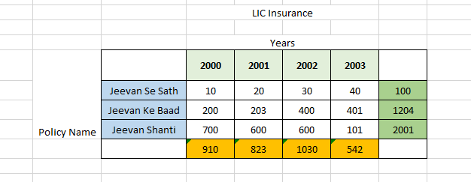

Object 1 🡪 LIC Policy (Text Field “Policy Name”)

Object 2 🡪 Growth (Master-Detail (LIC Policy), Year (Picklist), Amount (Currency))